RFP NO: RFP24-003 DATE: JUNE 16, 2023
BUYER: Kelly Sloan, Purchasing Manager PHONE: (816) 271-4465

ADDENDUM #1

FUNDING DEPARTMENT: ATHLETIC INSURANCE AND MEDICAL

EQUIPMENT/SERVICES REQUESTED: ATHLETIC INSURANCE BROKER

PLEASE NOTE: SEE BELOW FOR CLARIFICATIONS AND ADDITIONAL INFORMATION: PLEASE SUBMIT THIS INITIALED ADDENDUM WITH YOUR BID RESPONSE.

- Who is your current insurance broker and insurance carrier for your athletic insurance?
Dissinger Reed/HUB International.

- Does your current broker charge an administrative fee or are they paid commission by the insurance carrier?
MWSU deems this information not necessary for bidders to respond to this RFP. On the pricing sheet we are requesting your preferred method that is helpful to MWSU to evaluate our options.

- How much does your current insurance broker charge annually for their services?
MWSU deems this information not necessary for bidders to respond to this RFP. On the pricing sheet we are requesting your preferred method that is helpful to MWSU to evaluate our options and what we are currently paying isn’t relevant to your proposal.
- What is your current premium for your secondary athletic insurance premium?
$25,000.

- Is your current athletic insurance policy a fully insured policy or an aggregated deductible plan?
Aggregate Deductible.

- On average, how many short-term plans is the University purchasing for student athletes?
MWSU deems this information not necessary for bidders to respond to this RFP.

- Can you please provide the last 4 years paid claims and premiums for Athletic Insurance Services?
MWSU deems this information not necessary for bidders to respond to this RFP as we are asking vendors to showcase their abilities as a broker. Here are the paid claim totals so vendors may understand the scope of our program. The historical premiums and detailed loss information are irrelevant to respond to the RFP for an insurance broker. Once the award is made, the selected broker will be provided detailed claims reports and anything else they need to properly underwrite our program and provide carrier quotes.

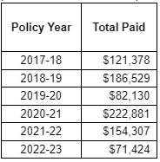

- Can you please provide a list of covered sports for men and women along with the number of athletes per sport?
MWSU deems this information not necessary for bidders to respond to this RFP as noted in response to question 7.

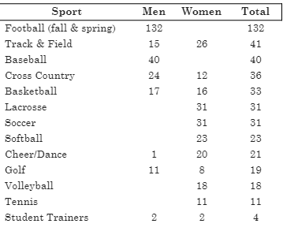

THIS ADDENDUM IS HEREBY CONSIDERED TO BE A PART OF THE ORIGINAL BID SPECIFICATIONS AND NEEDS TO BE INITIALED AND RETURNED WITH YOUR BID IN ORDER TO BE CONSIDERED.

