View Document

Login to Banner 9 Self Service Gold Link
Go to Finance & Requisitions and click on “Check Available Balance”
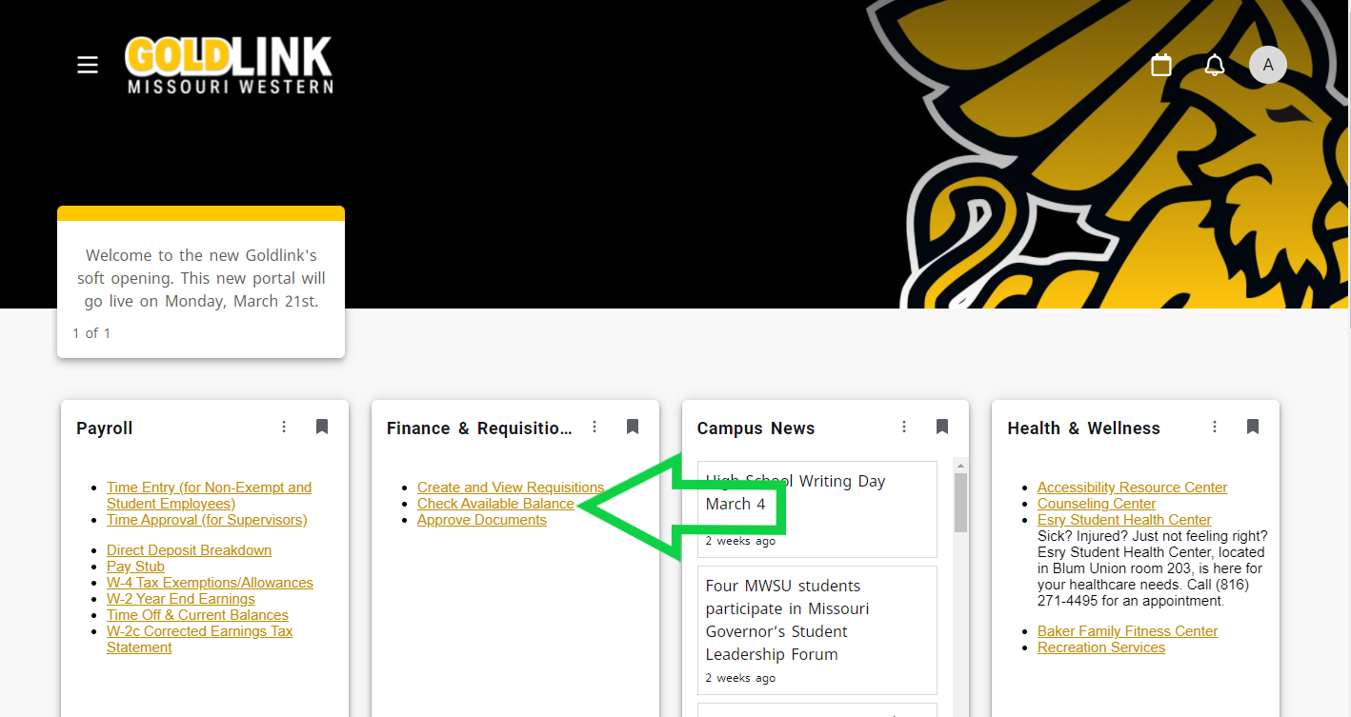
Click on the document icon
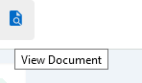
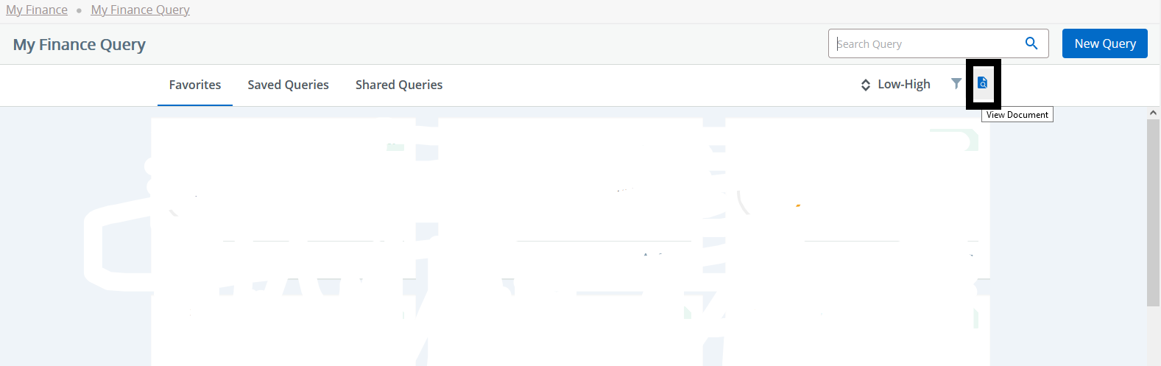

Document Type: Choose Requisition (if you have an R#), Purchase Order (if you have a PO #), Invoice ( if you have an I number) or Journal Voucher (if you have a J #)
Document Search: Leave Blank
Document Number: Type in your #
Click View Document (do NOT hit enter)
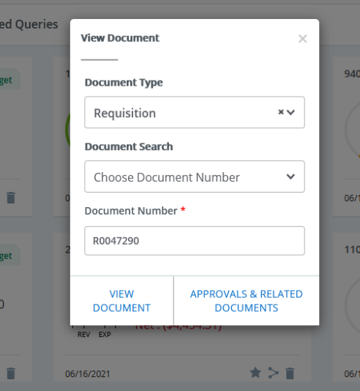

A PDF with the requisition/purchase order/ etc info will pop up
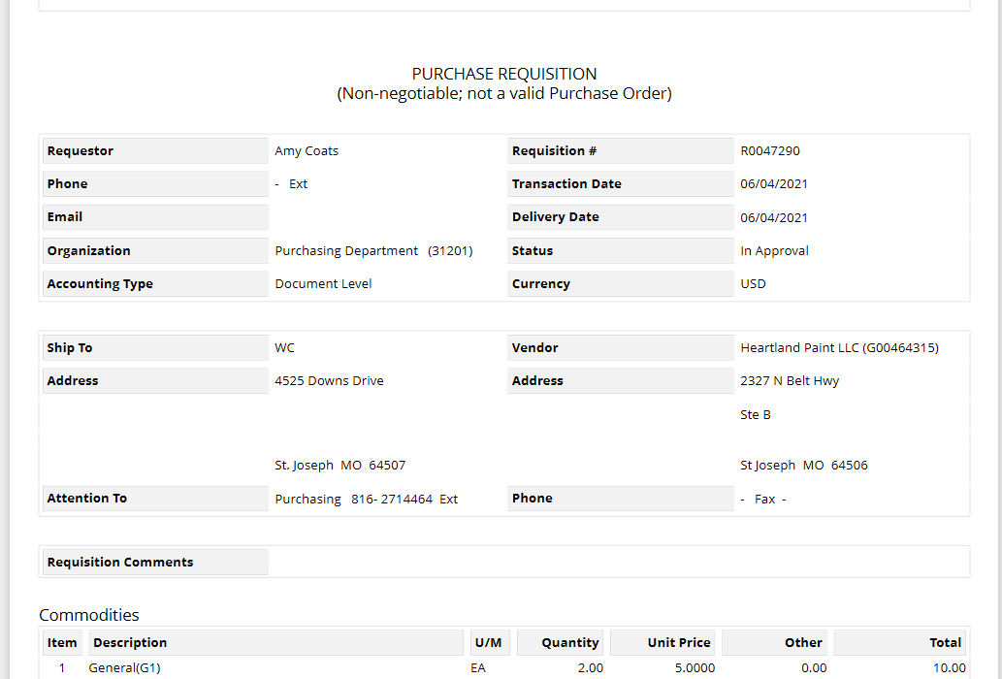

←

To View the payment information, click on “approvals & related documents”
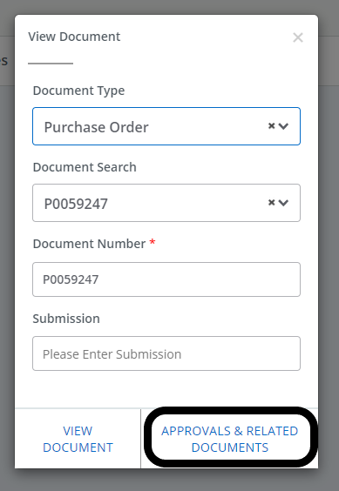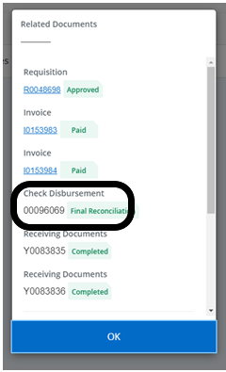

You can then click on the blue invoice #s for more information.
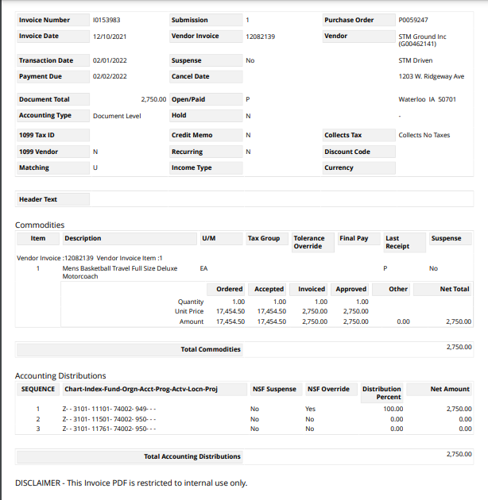

From here you can download into a folder should you need to keep a copy for your records
