FB NO: FB23-001 DATE: APRIL 19, 2022
BUYER: Kelly Sloan, Purchasing Manager PHONE: (816) 271-4465

ADDENDUM #1

FUNDING DEPARTMENT: ADMISSIONS

EQUIPMENT/SERVICES REQUESTED: PRINTING OF 2022-23 ADMISSIONS PUBLICATIONS PACKAGE

PLEASE NOTE: SEE BELOW FOR CLARIFICATIONS AND ADDITIONAL INFORMATION: PLEASE SUBMIT THIS INITIALED ADDENDUM WITH YOUR BID RESPONSE.

- Re: MWSU_23_15. Is the trim size the same as the finished size? Finished size 11-1/2 x 6-1/8.
Yes, that is correct. The project should be 11-1/2 x 6-1/8.
- Re: Stair-Step cards. Is the 5-1/2 x 8-1/2 the smallest or the largest size? What are the differences in the 5 pieces? Just the size?
This will be the smallest of the stairstep cards. We are concerned that they listed the card as a 5 1/2 x 8 1/2 when it is actually listed in the RFP as 8.5 x 5. Maybe this was misread regarding the size or misunderstood the height vs. width on this piece.
The difference in the five pieces is only in the height of the cards and the printed content. There are no other differences. See image
- Re: Acceptance Folders. We are confused on the size/pockets – flap/semi-circle die cut. Do you have an example or pictures that you could send? Or more information?
Please see the attached pictures of the front, back, inside and disassembled acceptance folder.
Photos:
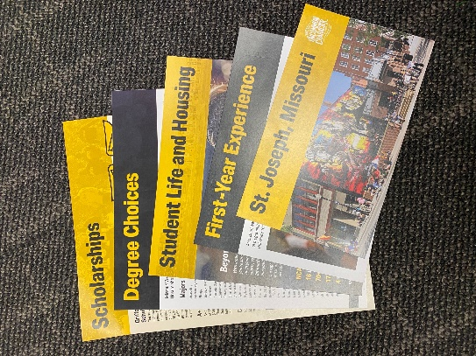
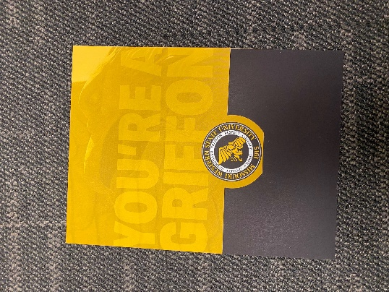

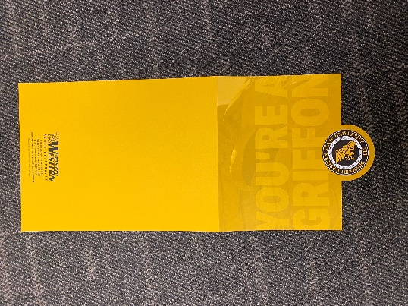

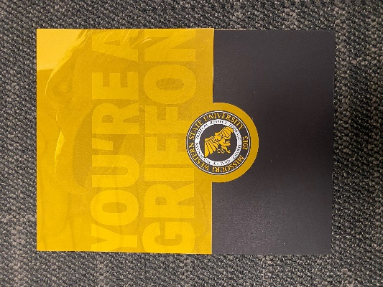

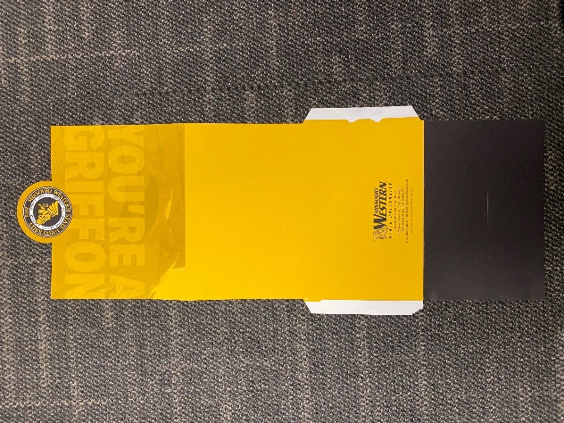

THIS ADDENDUM IS HEREBY CONSIDERED TO BE A PART OF THE ORIGINAL BID SPECIFICATIONS AND NEEDS TO BE INITIALED AND RETURNED WITH YOUR BID.

