MECHANICAL ANALYSIS
REMINGTON-AGENSTEIN SCIENCE BUILDING

MISSOURI WESTERN STATE UNIVERSITY
ST. JOSEPH, MO

August 25, 2017

PART 1 - EXECUTIVE SUMMARY

Remington-Agenstein Science Building at Missouri Western State University consumes significantly more energy than typical science buildings of similar size and occupancy. Much of this excessive consumption is due to the large number of constant volume fume hoods in the building, and the high rates of supply air in many spaces. We analyzed fume hood and exhaust and recommend several approaches to reducing energy in the building. We also did rough cost estimates and energy savings calculations for the options. The results are summarized below.

PART 2 - INTRODUCTION

The purpose of this report is to review the systems and operations in the Remington–Agenstein Science Building on the campus of Missouri Western State University. The goal is to identify opportunities to reduce energy consumption in the facility. The building houses classrooms, department offices, teaching laboratories, prep rooms, and research laboratories. The laboratories, which consume the majority of energy in the building, encompass approximately 25,000 square feet located on three floors of the building. In many aspects, the laboratories do not meet current standards, guidelines and/or best practices for laboratory operation.

PART 3 - EXISTING CONDITIONS

3.1 GENERAL DESCRIPTION
The original building, Agenstein Hall, was constructed in 1969. A new wing, Remington Hall was added in 2008. Agenstein Hall was fully renovated at that time. Each wing of the building has three occupied floors and a penthouse which houses mechanical equipment.

The building includes the following departments:
- Computer Science, Math, and Physics (CSMP)
- Chemistry
- Biology

Each of these departments has numerous dedicated prep rooms and teaching laboratories. CSMP, Biology, and Chemistry also have research laboratories. The Biology Research program includes a small animal housing and research area. Many of the laboratories and prep rooms are exhausted from chemical fume hoods, biological safety cabinets, snorkels, general exhaust, and/or chemical storage cabinet exhausts.

3.2 EXHAUSTED EQUIPMENT
Existing fume hoods are Labconco – Protector Laboratory Hoods in nominal 4-foot and 6-foot sizes. All hoods are operating at constant volume. Minor modifications to the existing hoods would allow them to operate in a variable volume configuration. Hoods are balanced to maintain approximately 65 FPM face velocity across an 18” sash opening. Drawings located in Appendix A indicate all hood locations.

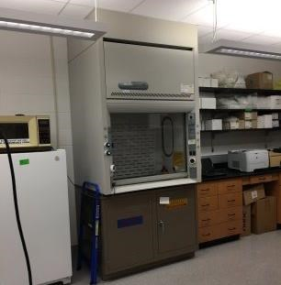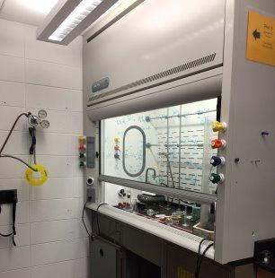
Figure 1: MWSU R-A Typical Laboratory Fume Hoods

Existing Justrite Flammable Liquid Storage Cabinets are located in the facility. All cabinets are designed to exhaust 50-60 CFM constantly. Appendix A indicates all bio-safety locations. Remaining exhausted equipment includes various snorkel exhaust and general exhaust outlets in the labs and lab support spaces.

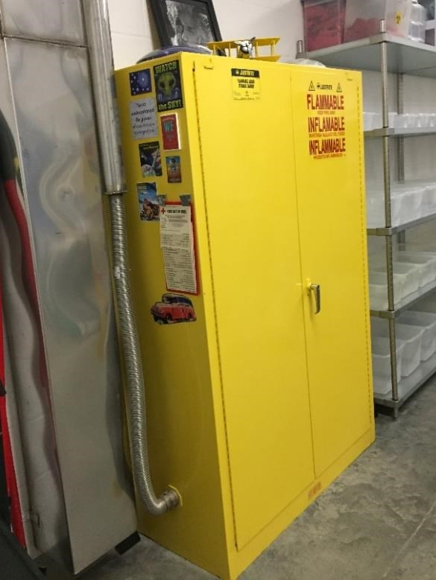
Figure 2: MWSU R-A Typical Bio-safety Cabinets

The following table lists rooms with exhausted equipment:

ROOM  # | ROOM NAME | EXHAUSTED DEVICE | # | EXHAUST  EACH -  CFM | TOTAL EXH-  CFM | EXH  FAN
114D | Chemical Hazardous Waste | Flammable Storage Cabinets | 3 | 50 | 150 | A6
114D | Chemical Hazardous Waste | 4 ft. Chem Fume Hood | 1 | 300 | 300 | A6
114C | Chemical Storage | Flammable Storage Cabinets | 5 | 50 | 250 | A6
114C | Chemical Storage | 4 ft Chem Fume Hood | 1 | 300 | 300 | A6
114C | Chemical Storage | General Exhaust | 3 | 160 | 480 | A6
114B | Chemical Acid Storage | Acid Storage Cabinets | 4 | 50 | 200 | A6
114B | Chemical Acid Storage | General Exhaust | 1 | 200 | 200
114A | Chemical Dispensing | General Exhaust | 3 | 120 | 360 | A6

3.3 HVAC SYSTEM
The facility is served by a 4 pipe Heating Ventilation and Air Conditioning (HVAC) system. Air-cooled chillers and condensing heating hot water boilers provide chilled and hot hydronic water. The 4 pipe system serves (4) variable volume air handling units (AHUs) sized at the below airflows. The air handlers are located in rooftop penthouses.

AHU-A1 – 10,000 CFM
AHU-A2 – 10,000 CFM
AHU-R1 – 14,000 CFM AHU-R2 – 14,000 CFM

Medium pressure supply ductwork with single duct terminal units supply each laboratory. Hot water hydronic heating is included in each room duct terminal unit for temperature control.

Constant volume, high plume exhaust fans serve all laboratory exhaust equipment. Laboratory exhaust fans are sized at the below airflows.
EF-A1 and A2 – 5,500 CFM
EF-A3 – 3,820 CFM
EF-A6 – 8,085 CFM
EF-R1 – 4,800 CFM
EF-R2 – 6,500 CFM
EF-R3 – 5,900 CFM
EF-R4, R5, R6, and R7 – 5,700 CFM

PART 4 - ANALYSIS

4.1 FUME HOOD QUANTITY
The number of fume hoods operating at constant volume is on primary reason for the facility’s excessive energy usage. The Remington-Agenstein Hall has 68 fume hoods scattered throughout the facility. The fume hoods account for approximately 31,000 CFM and operate constantly, 24 hours every day. Because of this, air handling equipment is required to provide over 31,000 CFM of conditioned outdoor air 24 hours per day to provide adequate makeup air. Boilers and chillers must provide chilled and heating hot water to condition the makeup air that is supplied continuously. The result is a building that consumes excessive amounts of energy.

4.2 FUME HOOD CONTROL
All of the fume hoods in the Remington-Agenstein Hall are constant volume. This contributes to the excessive energy consumption. ASHRAE Standard 90.1, Energy Standard for Buildings, and current energy codes require fume hoods to be designed for variable volume airflow operation. Variable volume fume hoods allow for makeup supply air to be reduced when the fume hood sashes are lowered. This results in significant energy reduction.

4.3 ROOM AIR CHANGE RATES
Current laboratory design approaches typically use air exchange rates of approximately 6 air changes per hour (ACH) when occupied and 4 air changes per hour (ACH) when unoccupied. These values are guidelines, but represent the current state of the art in the industry. Our analysis shows that multiple rooms in the building have air change rates in excess of 6. Some are operating at 7-10 ACH, delivering excessive supply airflow quantities. Reduction in room ACHs will lead to reduced energy consumption by supply fans, pumps, chillers, and boilers.

4.4 BUILDING PRESSURIZATION
When the pressure inside a building is lower than the pressure outside, the building is “negative” with respect to the outdoors. Untreated outdoor air will push its way into the building by means of infiltration. When the pressure inside a building is more than the pressure outside, the building is “positive” with respect to the outdoors. Conditioned indoor air will force its way out of the building by means of exfiltration.
For all buildings it is important to maintain positive building pressurization at all times to avoid excessive infiltration. Excessive infiltration through cracks & joints, doors opening, etc. could cause moisture migration into the building, increase building loads, disrupting temperature control, and increasing the likelihood for mold growth inside the building envelope.

PART 5 - RECOMMENDATIONS

5.1 OPTION #1 - FUME HOOD REDUCTION
Fume hood operation evaluation and reduction is recommended for the facility. The quantity of fume hoods for the current curriculum appears to be excessive for a typical higher education facility. Reducing fume hoods would have a significant impact on total building energy usage.

Another option for reducing fume hood quantities would be to implement shared teaching laboratories between sections within a department, and potentially between departments. Teaching laboratories would be set up to be flexible to accommodate varying needs. Class scheduling would need to be carefully analyzed to determine how many flexible teaching labs could be shared.

Reducing exhaust airflow will allow for reducing outside and supply airflow. This will allow supply fans, chillers, boilers, and pumps to reduce their energy consumption. Additional discussion with university staff will be required to determine how many hoods could be decommissioned or removed.
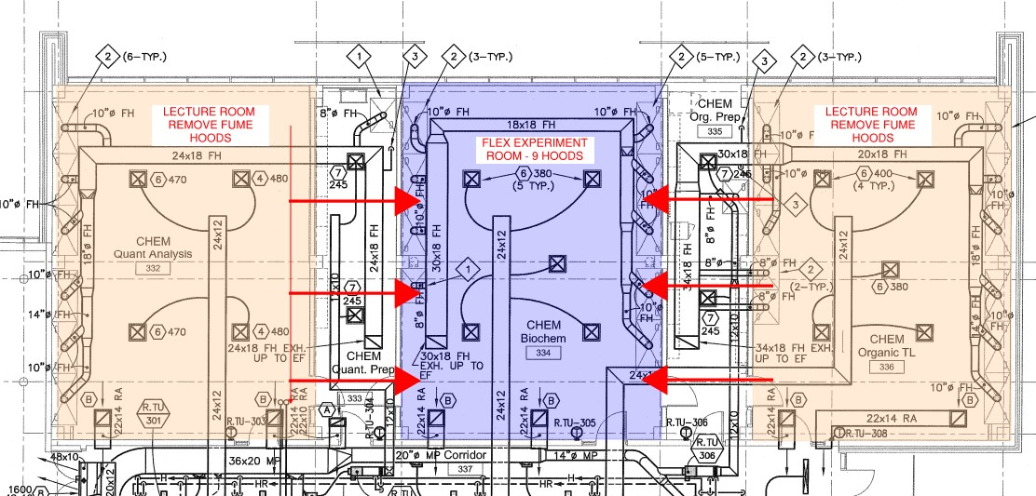
Figure 3: MWSU R-A Typical Centralized Experiment Room Layout

5.2 OPTION #2 – SUPPLY AIR REDUCTION
Laboratory supply air reduction and rebalancing is recommended for the facility. Most laboratory spaces are delivering air to the rooms at 7-10 ACH. Rooms should be rebalanced to deliver a maximum of 6 ACH to an occupied room if fixed exhaust and room pressure allows. Table 1 shows rooms where rebalancing could be considered.
Delivering supply air at 6 ACH will result in reduction of approximately 7,250 CFM in supply airflow. Reduction in supply airflow will allow supply fans, chiller, boiler, and pumps to operate at reduced energy consumption.

 | MWSU Remington - Agenstein Lab Room Invento |  |  |  |  |  | ry
Level | Room | W | L | H | Volume | Room Airflow | ACH | Total Room Lab Exhaust
1W | CHEM Hazardous Waste | 14 | 22 | 10 | 3,080 | 350 | 7 | 750
2W | BIOLOGY Anatomy & Physiology | 36 | 29 | 10 | 10,440 | 1,510 | 9 | 720
2W | BIOLOGY Research Stations 211 | 36 | 31 | 10 | 11,160 | 1,400 | 8 | 300
2W | BIOLOGY Research Stations 213 | 27 | 30 | 10 | 8,100 | 1,010 | 7 | 300
2E | BIOLOGY Microbiology 233 | 29 | 41 | 10 | 11,890 | 1,830 | 9
2E | BIOLOGY Microbiology 236 | 28 | 41 | 10 | 11,480 | 1,760 | 9
2E | BIOLOGY Micro Mol/Gen Prep | 10 | 41 | 10 | 4,100 | 510 | 7 | 500
2E | BIOLOGY Genetics | 29 | 41 | 10 | 11,890 | 1,840 | 9
2E | BIOLOGY Ecology | 29 | 41 | 10 | 11,890 | 1,980 | 10 | 500
2E | BIOLOGY Ecology Prep | 10 | 41 | 10 | 4,100 | 530 | 8 | 300
2E | BIOLOGY General Biology 252 | 28 | 41 | 10 | 11,480 | 1,920 | 10 | 500
2E | BIOLOGY General Bio Prep | 10 | 41 | 10 | 4,100 | 530 | 8 | 300
2E | BIOLOGY General Biology 254 | 29 | 41 | 10 | 11,890 | 1,980 | 10 | 500
3W | CHEM Physical Chem | 44 | 31 | 10 | 13,640 | 1,680 | 7 | 300
3E | CHEM Gen Chem Prep | 10 | 41 | 10 | 4,100 | 800 | 12 | 400
3E | CHEM Instrumental Room | 10 | 19 | 10 | 1,900 | 560 | 18 | 300
3E | CHEM Instrumental TL | 30 | 41 | 10 | 12,300 | 1,800 | 9 | 60
Table 1: MWSU R-A Air Change Rate Table

5.3 OPTION #3 – CONFIRM BUILDING PRESSURIZATION
Air balance calculations for the existing design airflows show the building positive when AHU return fans operate at 60% airflow. Air handling units or exhaust fans operating at airflows greater or less than design values could have a significant impact on building pressurization. As-built control drawings show AHU return fans operate to maintain an average return plenum static pressure set point of 0.2 in H2O. The building should be pressurized to 3,000-3,500 CFM given the age and size of Remington-Agenstein Hall. Our anecdotal observation from our site visit is that the building was operating under negative pressure. Detailed test and balancing should be performed to confirm the building is operating at the recommended airflow pressurization.

5.4 OPTION #4 – FUME HOOD CONTROL UPGRADES
Upgrade of fume hood controls will have a significant impact on the facility’s energy usage. Laboratories would be upgraded for variable volume airflow by installing airflow control valves (Phoenix, or Siemens) and controlling airflow to fume hoods, supply, and general exhaust. The valves will be controlled to maintain proper face velocity at the hood, and to control the specific pressure relationship required by maintaining a fixed offset either into or out of the lab. Generally speaking, all labs will maintain negative pressure relative to adjacent spaces.

Each fume hood will have a valve and each laboratory will have a general exhaust valve (or valves). These valves will be controlled to maintain a volumetric offset for each room. The hood exhaust and general lab exhaust will be combined downstream of their respective valves and be served by the existing rooftop high induction type mixing fans.

PART 6 - OPINION OF COSTS

6.1 APPROXIMATE CONSTRUCTION COSTS
The following Table 2 outlines ballpark costs for the above proposed options at the Remington-Agenstein Hall. All opinions of probable costs are based on RS Means Online Estimating Tools, Henderson’s experience from similar past projects, and information from local equipment manufacturer representatives. All costs should be considered as order of magnitude and should not be used for budgeting purposes.

 | Option | Cost
Option #1-#3 |  | $80k-$100k
Option #4 |  | $650k-$750k
 | Opinion of Overall Probable Costs | $730k-$850k

Table 2: Opinion of Probable Costs

6.2 SIMPLE PAYBACK – OPTIONS #1-#3

The following Table 3 outlines an order of magnitude simple payback on the HVAC improvements for the above proposed work related to Options 1# through #3.

Fan and chiller savings (kWh) | 1,250,000-1,550,000
Total Annual Electric Consumption Cost Savings | $95,000-$117,800
Boiler Savings (CCF) | 720,000-900,000
Total Annual Gas Consumption Cost Savings | $39,000-$48,850
Total Annual Consumption Cost Savings | $134,000-$166,650
Option #1-#3 First Cost | $80k-$100k
Opinion of Simple Payback (years) | <1 year
*Utility rate assumptions - $0.0543/1 CCF (MWSU utility bills), $0.076/kWh (MWSU utility bills)
Table 3: Opinion of Simple Payback

The following are assumptions made for the above energy savings calculations:
- System is rebalanced to at least a 20% reduction in total fume hood exhaust airflow
- Total energy usage determined by assuming AHU-A1, A2, R1, and R2 operate at 24 hours, 7 days a week. Outdoor air temperatures determined using typical BIN weather data for Kansas City, MO. Total supply airflow was reduced at the following ratios:
  - OA Temp 81-103F – 100% SA airflow building wide
  - OA Temp 55-80F – 85% SA airflow building wide
  - OA Temp 5-54F – 75% SA airflow building wide
- Total energy usage determined by assuming all laboratory exhaust fans operate at 24 hours, 7 days a week.
- Chiller plant efficiency of 1.23 kW/ton

6.3 SIMPLE PAYBACK – OPTIONS #4

The following Table 4 outlines the anticipated payback on the HVAC improvements for the above proposed work related to Option#1 through #4. It is assumed all improvements would be completed if the system was converted to variable volume fume hood exhaust.

Fan and chiller savings (kWh) | 2,280,000-2,850,000
Total Annual Electric Consumption Cost Savings | $173,250-$216,600
Boiler Savings (CCF) | 1,912,000-2,390,000
Total Annual Gas Consumption Cost Savings | $103,800-$129,750
Total Annual Consumption Cost Savings | $277,050-$346,350
Option #1-#4 First Cost | $730k-$850k
Opinion of Simple Payback (years) | 2-4 years
*Utility rate assumptions - $0.0543/1 CCF (MWSU utility bills), $0.076/kWh (MWSU utility bills)
Table 4: Opinion of Simple Payback
The following are assumptions made for the above energy savings calculations:
- Same assumptions were made as stated in Options #1 through #3.
- Laboratory classrooms are occupied annually 40 weeks, Monday through Friday from 7:00am to 4:00pm. During classroom occupancy all hoods are operational. Hood airflow during classroom occupied and unoccupied times are assumed as follows:
  - 6’ Hood (Occupied) – 500 CFM
  - 6’ Hood (Unoccupied) – 250 CFM
  - 4’ Hood (Occupied) – 300 CFM iv. 4’ Hood (Unoccupied) - 165 CFM

