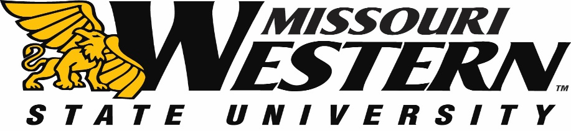
BID SPECIFICATION SHEET FOR FB18-088
GRIFFON MASCOT COSTUME FOR MISSOURI WESTERN STATE UNIVERSITY

Scope of Work:
MWSU would like to purchase a custom made Griffon Mascot costume, with optional carrying bag and cooling vest.
Timeline of Project:
- MWSU would like to have this Mascot costume received by May 31, 2018.
Bid Specification:
Design a custom Griffon Mascot costume with the following:
- hand-carved, hand-covered head with battery operated ventilation fan
- inner or upper body padding (where applicable)
- two piece fur body, with defined muscles in arms
- tail
- wings
- cartoon mascot gloves with claws
- "walkabout" animal paw feet with claws
Please also price the following optional add-on items
- cooling vest
- carrying bag

Return the pricing sheet (page 2) with your bid. Shipping costs must be included in the Mascot pricing and not as separate line item. Pricing must be FOB Missouri Western State University.
Include W-9/W-8 as well as any addendum(s) with your initials with your pricing sheet.

All questions should be directed to Purchasing Manager, Kelly Sloan, (816) 271-4465, purchase@missouriwestern.edu

Bid Submission Requirements:
Sealed bids must be submitted to the Purchasing Office by 2:00 p.m. Central Time on March 13, 2018 in Popplewell Hall, Room 221, 4525 Downs Drive, St. Joseph, MO 64507. Electronic or faxed bids will not be accepted. Missouri Western reserves the right to accept or reject any or all bids.
BID SPECIFICATION SHEET FOR FB18-088
GRIFFON MASCOT COSTUME FOR MISSOURI WESTERN STATE UNIVERSITY

Custom Mascot Bid Amount $_______________________ (following specs above, including any shipping costs)
Cooling Vest Bid Amount $ _________________________
Carrying Bag Bid Amount $__________________________

Company _________________________________________________

Authorized Signature Date ______________

