Kansas City Northland Campus

Perforated Vinyl Window Graphics Project

Missouri Western State University is seeking bids from vendors to print and install perforated vinyl window graphics at its Kansas City Northland Campus located at 6364 North Cosby, Kansas City, MO 64151.

PROJECT SPECIFICATIONS:
All panels are 4-color
Material: perforated vinyl, laminated
Window Measurements:
Panel A – 53.625” x 100” – 37.24 sq ft
Panel B – 17.125” x 100” – 11.89 sq ft
Panel C – 14.25” x 100” – 9.9 sq ft
Panel D – 37” x 31.75” – 8.16 sq ft
Panel E – 27” x 72” – 13.5 sq ft
Panel F – 13.9375” x 100” – 9.68 sq ft
Panel G – 17.4375” x 100” – 12.11 sq ft
Panel H – 53.625” x 100” – 37.24 sq ft
Panel I – 53.625” x 100” – 37.24 sq ft
Panel J – 16.875” x 100” – 11.72 sq ft
Panel K - 17.4375” x 100” – 12.11 sq ft
Panel L – 54.125” x100” – 37.58 sq ft
Panel M – 58.375” x 100” – 40.53 sq ft
Panel N – 17.875” x 100” – 12.41 sq ft
Total window square feet: 291.31 sq. ft.

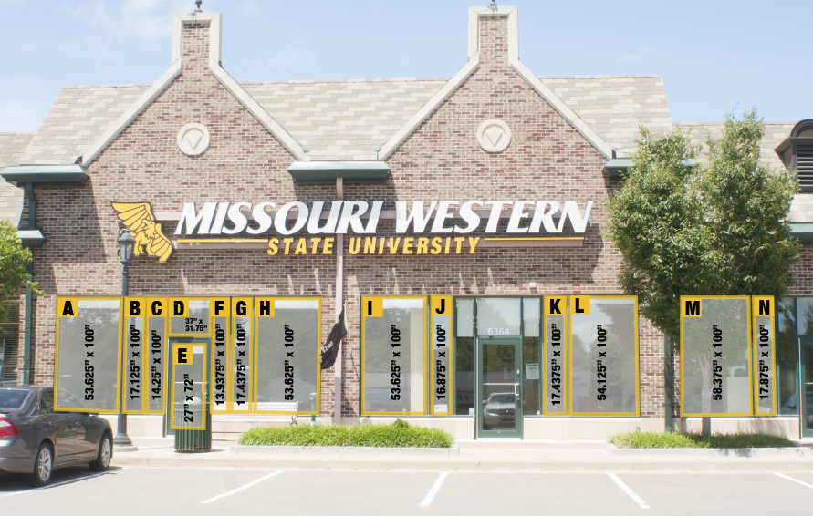

*Note: Panel I will have a large rectangle cut out so that a television screen can be seen behind the glass.
SAMPLE DESIGN:

*Note: This design is subject to change until the file submission date.

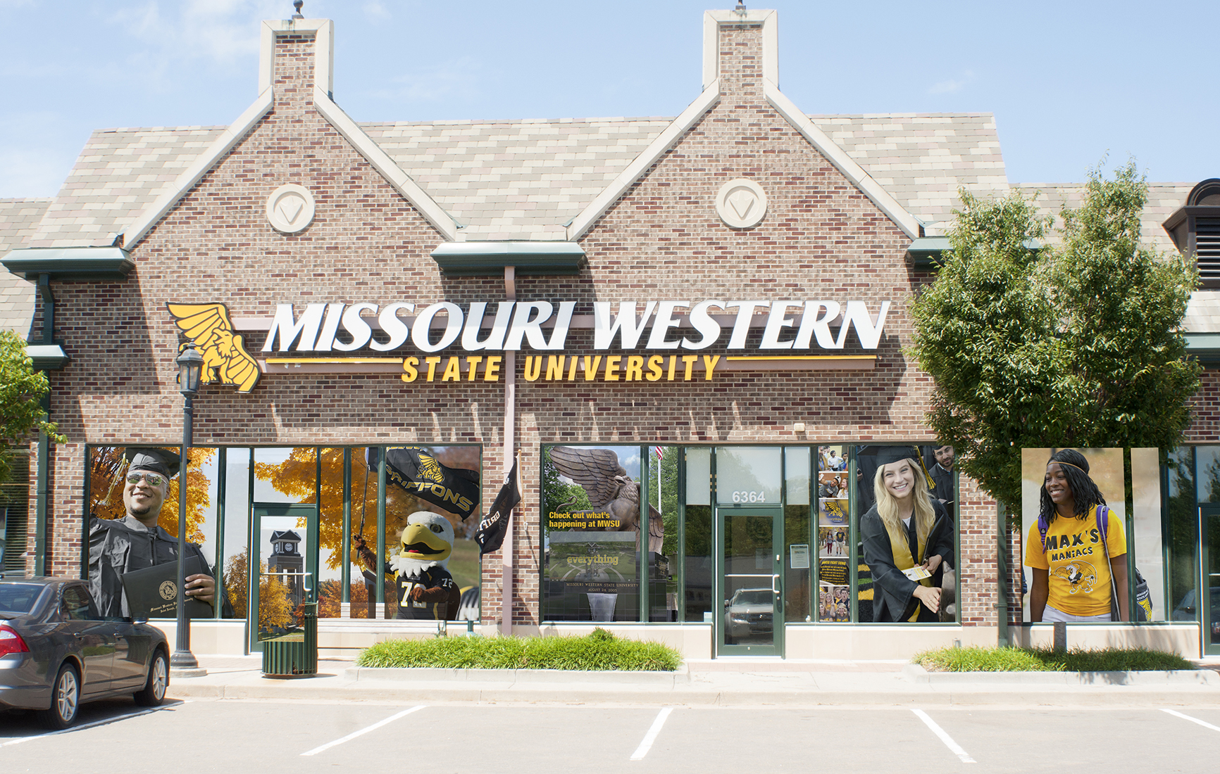

SITE VISITS:

Vendors may stop by the Northland Campus at any time M-F 7:30 a.m.-4:30 p.m. to inspect the site and/or take additional measurements.

Address:
6364 North Cosby
Kansas City, MO 64151
(Located at the Village at Burlington Creek, just off 64th street near I-29.)

Phone:
(816) 746-1001

Open Hours:
Monday through Friday 7:30 a.m. to 4:30 p.m.

PERMIT NOTE:

MWSU requests that the vendor work with City of Kansas City to secure any permits required for this project (if any).

PROJECT DATES:

Deadline for FB submission September 2, 2016

Winning FB notified on or before September 9, 2016

MWSU will submit the final design on or before September 16, 2016
(Files will be submitted in the format requested by vendor.)

Installation deadline on or before October 17, 2016

VENDOR SAMPLES:

With your bid, please submit at least two sample photos of window graphics previously printed and installed by your company at local businesses. Please note the address of each sample so that MWSU can review the quality of the print and installation. Vendors that do not submit samples will not be considered.

BID SUBMISSION REQUIREMENTS:

Sealed bids must be submitted to the Purchasing Office by 2:00 p.m. CDT on September 2, 2016 in Popplewell Hall, Room 221. Electronic or faxed bids will not be accepted. Missouri Western reserves the right to accept or reject any or all bids. Pricing must be FOB Missouri Western State University. All items must be new, first quality.

MWSU reserves the right to award to the bidder whose bid complies with all mandatory specifications and requirements and is the lowest and best bid for supplies. Bid will be evaluated and awarded as a whole; to one vendor.
Return this pricing sheet with your bid. Include any addendum(s) with your initials.

All questions need to be directed to Kelly Sloan, Purchasing Manager purchase@missouriwestern.edu
Please include your company’s W-9 with your bid documents.
PROJECT COSTS:

Cost to Print 291.31 sq. ft. of perforated vinyl _________________________________

Cost to install the perforated vinyl _________________________________

Any miscellaneous costs (please detail) _________________________________

TOTAL COST _________________________________

Vendor Authorized Signature________________________________________________________
Date______________________________________________________

