

Vol. 21 Spring 2023

Newsletter

## New faces within the Honors program

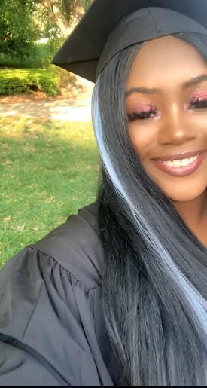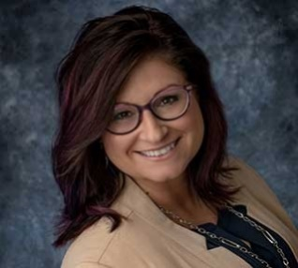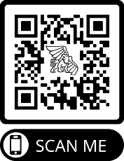

## colloquia spotlight

The Honors Program has welcomed two new faces this year! Zaya Webb is our new Honors Program Office Assistant. Zaya is a Freshmen this semester and is majoring in Nursing.

Each semester, departments across campus offer a variety of general studies honors and colloquia courses designed for 10 to 20 students. One of the unique features of the Honors program is the colloquia, which are theme-based experiences involving panel discussions, presentations, guest speakers, outside readings, films, and field trips. Professors from across campus apply to teach colloquia which are selected by the Honors Committee. Different colloquia are offered each semester, and recent colloquia topics include Learning and the Brain, Conserving Biodiversity, Freedom, Identity, and the Good Life, Science Communications, Seven Glasses: The Chemistry and History of Beverages, and Healthy Relationships: Yes, It Does Matter. This upcoming fall semester we will be offering HON 195-01: Whodunit? The History and Philosophy of Solving Mysteries, HON 195-02: From Kaiju to Killer Bugs: Societal Fears of Science in American Cinema, and HON 395-02: A Journey Through the World of Biogeography.

## Why join the honors program?

Students join the Honors Program for many different reasons. Some of the main reasons are all the benefits that come with being an Honors student. Here are just a few of the benefits you could receive if you join the Honors Program today!

* Priority Registration (you get to enroll in classes the same time seniors do!).
* Smaller class sizes with more in-depth active learning.
* You will receive a medal to wear at graduation and have an Honors designation on your official college transcripts.
* You will have access to our newly renovated lounge where you’ll have computers, printers, a fridge and microwave, and a quiet place to hang out or study.

Dr. Becky Gregory is our newest Honors Committee Member. Dr. Gregory is an Assistant Professor for the Nursing Department. She received her B.S.N at Missouri Western State University and continued on to the University of Missouri-Kansas City where she received her M.S.N and her Ph.D.

Welcome Zaya and Dr. Gregory!

To apply to the Honors Program, and to find out more information, scan the two QR codes found at the bottom of the pages of this newsletter!



Newsletter

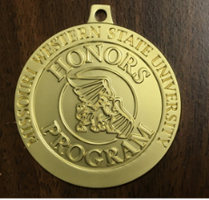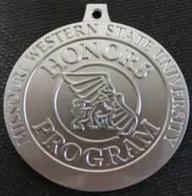

## Congratulations Spring Class of 2023!

## graduating seniors!

Devin Bensyl, Management and Marketing

Bailey Daniels, Nursing

Jennifer Dorris, Chemistry

Zoe Dunn, Performing & Cinematic Arts

Devin Eckardt, Performing & Cinematic Arts

Erin Ellington, Digital Animation

Kylie Gardner, Nursing

Sumer Green, Elementary Education

Zachry Hanlan, Physical Education

Danielle Hayden, Biology

Logan Hovey, Biology

Gabriele King, Studio Art

Konner Larkin, Wildlife Conservation & Management

Barak Mareske, Digital Animation

Kylie Mathis, Accounting and Finance

McKenna Mavel, Nursing

Kylee Meehan, Psychology

Jordan Miller, Political Science

Hannah Shoemaker, Biology

Madison Spath, Performing & Cinematic Arts

Jude Stapf, Chemistry

Mona Tajchman, Graphic Design

Tori Willis, Psychology

Bowyn Ziebarth, Biochemistry/Molecular Biology and Chemistry

Each semester, the Honors Program hosts its biannual Medal Ceremony. All graduating seniors are given a certificate of completion for completing the Honors Program requirements. Students are also given a medal for them to wear during Commencement. Students receive either a gold or silver medal depending on the program that they completed. The gold medal represents the completion of Majors Honors and the silver medal represent the completion of General Studies Honors. This semester, there are twenty-five graduating Honors students. There will be twenty- four students graduating with General Studies Honors and one student graduating with Majors Honors this semester. This ties with the largest graduating class since the spring of 2021 which also had twenty-five honors program graduates. It is the largest class since the spring of 2013 with thirty honors program graduates. We are so proud of all our Honors students and wish them continuing success throughout their careers!

## Honors program medal ceremony

## Contact Us: honors@missouriwestern.edu or (816) 271-4535

## Find us: Eder 220

## Visit: www.missouriwestern.edu/honors or scan the qr code